OSI Layer Model
Task – 1 : Draw a diagram of the OSI 7-layer model and label each layer with its correct name and a real-world example of a device or protocol that operates at that layer (e.g., Switch at Data Link, HTTP at Application).
Solution : OSI 7-Layer Model
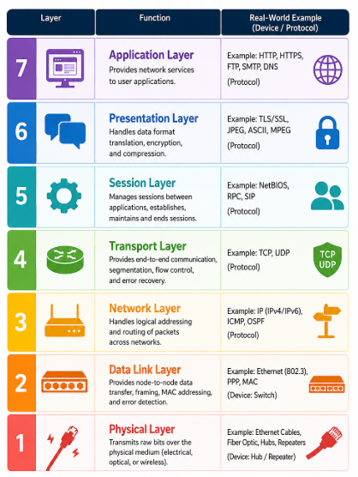
The OSI 7-layer model explains how data travels from one device to another over a network:
- Application – Provides network services to applications
- Presentation – Handles data formatting, encryption, and compression.
- Session – Establishes and manages communication sessions.
- Transport – Provides reliable data delivery, segmentation, and error control.
- Network – Handles IP addressing and routing between networks.
- Data Link – Handles MAC addresses, frames, and local network communication.
- Physical – Transmits raw bits through cables, fiber, or wireless signals.
Task – 2 : Match the following networking scenarios to the correct OSI layer: a) Encrypting data before sending, b) Routing packets across networks, c) Converting data to electrical signals, d) Opening a web page in your browser, e) Detecting and correcting errors in frames. Hint : Write your answers as 'Scenario: Layer Name (Layer Number)'.
Solution : Match the Scenarios to OSI Layers
a) Encrypting data before sending : Presentation Layer (Layer 6)
b) Routing packets across networks : Network Layer (Layer 3)
c) Converting data to electrical signals : Physical Layer (Layer 1)
d) Opening a web page in your browser : Application Layer (Layer 7)
e) Detecting and correcting errors in frames : Data Link Layer (Layer 2)

Task – 3 : Pick any app you use daily (like WhatsApp, Instagram, or Zomato) and describe how at least three different OSI layers are involved when you send or receive data in that app.
Solution : OSI Layers Involved in WhatsApp
When I send a message through WhatsApp, multiple OSI layers work together to deliver the data.
1. Application Layer (Layer 7)
The WhatsApp application creates the message and communicates using application-level network services.
2. Presentation Layer (Layer 6)
The data is formatted and security mechanisms such as encryption are used to protect the communication.
3. Transport Layer (Layer 4)
Transport protocols handle communication between the devices and help manage the delivery of data.
4. Network Layer (Layer 3)
IP addressing is used to identify the source and destination, and routers forward packets toward the destination.
5. Data Link & Physical Layers (Layers 2 and 1)
The data is placed into frames and transmitted as signals through Wi-Fi/mobile networks.

Task – 4 : Given this scenario: You are unable to access a website, but you can successfully ping its IP address. Identify which OSI layer(s) might be causing the problem and explain your reasoning.
Solution : Website Cannot Open but IP Can Be Pinged
The problem is most likely at the Application Layer (Layer 7) or possibly the Transport Layer (Layer 4).
Since the IP address can be successfully pinged, the Network Layer (Layer 3) is working because IP packets are reaching the destination and returning successfully.
The issue could be with the Application Layer, such as the web server, HTTP/HTTPS service, or browser configuration. It could also be a Transport Layer problem if the required TCP port, such as port 80 (HTTP) or 443 (HTTPS), is blocked or unavailable.

